Booster Meeting Minutes
March 5, 2026
7:00 PM

Minutes- Posted on Band Webpage www.neoshoband.com
In Attendance:
Dan Duffield, Jill Denefrio, Alfred Hagan, Angie Francisco, Stephanie McConnaughey, Ryan Chapman, Karl Kriesch, Amanda Kriesch, Heather Clear

Financial Report
Motion made by Ryan Chapman to approve the financial report and seconded by Amanda Kriesch. The financial report was approved.
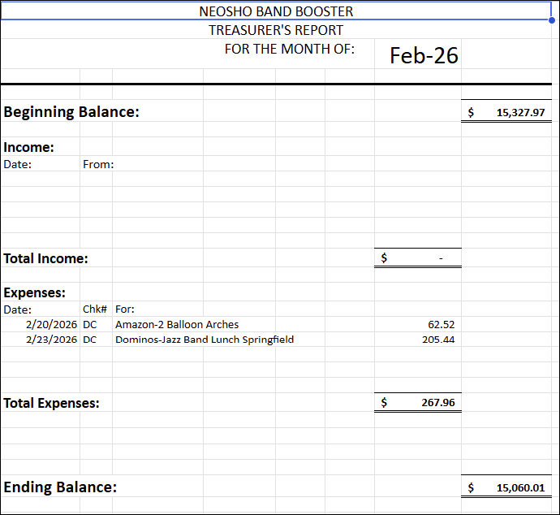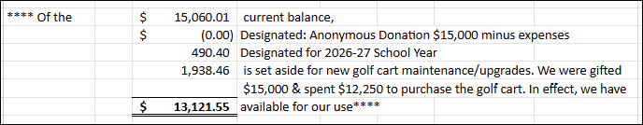
Uniform needs
Sewing & Hair Kits
- Need to have sewing and hair kits for color guard, in band room, and in trailer
Clean Uniforms
- Mr. Duffield will check with someone from school about cleaning the uniforms
Uniform fittings
2nd and 3rd week of band camp

Fundraisers
Direct a Song – Mr. Duffield will check with other directors
Date – 2027
Ticket cost – discuss early 2027
Coffee & Snacks
Pizza fundraisers with
- Dominoes – Alfred
- Papa Murphy – Heather Clear

Sell pizza at football games
- Jill will check with Teresa Jennings
Jr. High Fundraising: Amanda K asked about options to help band students for HS band dues

Band Events
Mar 6 - PSU Jazz Fest
Boosters provide snacks March 10 – Spring Band Concert: 6pm – 8pm
March 11 – Symphonic Band Recruitment Trip – All day March 28 – District Solo/Ensemble
April 2 – Band Festival – Lee’s Summit
Provide meal April 6 - State Competition
April 12 - Springfield Cardinal game April 15 – 16 – Vine Jazz Festival
April 28 – HS Awards Concert: 6pm – 8pm April 29 - 30 – State Solor/Ensemble
April 30 – JH/MS Spring Band Concert: 6pm – 7pm

Jazzam
Date: Saturday, April 18 Volunteers – Jill create Sign-up
Concessions Karl K - help with grilling
Hospitality room – Jill will get with Mrs. Gorman
Jazz Social
Date/time: Sunday, April 19 Cost: $20.00
Decorations – Jill Food & supplies – Heather, Stephanie, Amanda
Promote – flyer, Facebook event

Senior Scholarships – see information on page 3
Committee for Judging

Yearbook
- Amanda K will check about electronic options

Officer Nominations
Nominations will be accepted until March 31, 2026.

Other Business
D & O Insurance – Jill will check with insurance company Table Covering banners – Alfred will get quote
Medical bag – maybe add Narcam – Mr. Duffield will check with school nurse

Next regular Booster Meeting will be Tuesday, April 7 at 6:00 PM in the band room
Email: neoshowildcatband@gmail.com

