Booster Meeting Minutes
January 6, 2026

In Attendance:
Dan Duffield, Jill Denefrio, Alfred Hagan, Angie Francisco, Stephanie McConnaughey, Ryan Chapman, Karl Kriesch, Kael K

Minutes- Posted on Band Webpage www.neoshoband.com

Financial Report
November:
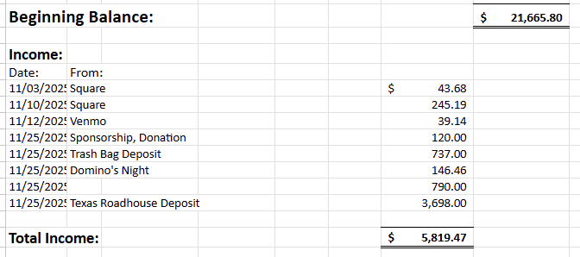

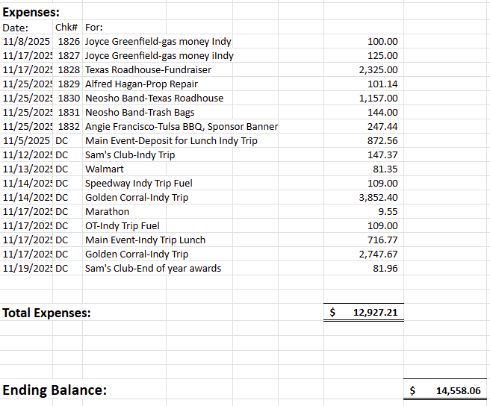
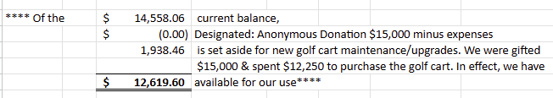

December:
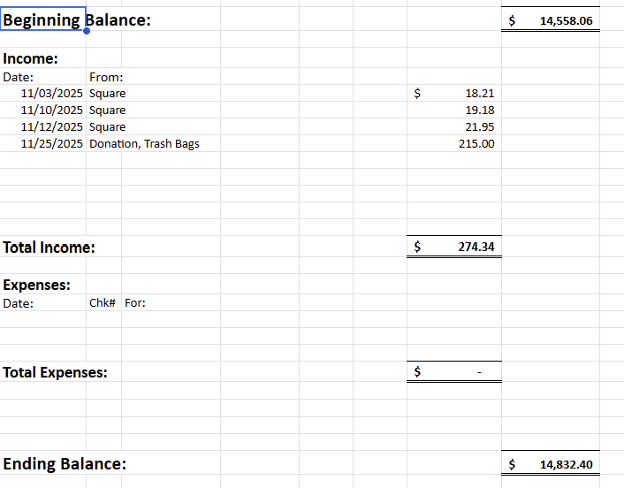

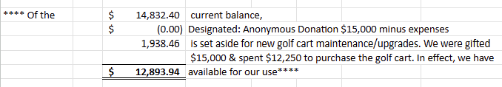

Motion made by Alfred Hagan to approve the financial report and seconded by Stephanie McConnaughey. The financial report was approved.

Pep Cats
Feed the students – 1/27 – use the BBQ that is in freezer

Organize Closet – need to set a date to work on the storage closet
Tote-to-go – put together a tote for travel events – for paper plates, napkins, forks, etc.
Sewing and hair kit – band room, take on trips and Color Guard
Put together Sewing and Hair kits
Uniforms to cleaners
- Mr. Duffield will reach out to Jr. High about cleaning the uniform bibs.

Fundraisers
Homecoming Dance – 01/24 @ Jr. High
- Jill will create tickets and get tickets for Mr. Duffield to print
- Sell tickets in the HS cafeteria during lunch – 1/21, 1/22 and 1/23
- Heather C will create a flyer – flyer will be printed and put up in the HS hallways
- Jill will build the sign-up genius for the dance

Chili and cinnamon rolls
Discussed having the chili and cinnamon fundraiser on 2/13

Table Covering banners
Got bids from:
Graphix
Flagship
Voted to purchase table banners – spend up to $1,000
A motion by Stephanie McConnaughey to purchase the table banners was seconded by Ryan Chapman. This was approved.

Other Business

1/17 – Jr. High Honor Band/HS Jazz Band
Hospitality room – boosters will provide food
Mr. Duffield will ask Mrs. Gorman to contact Jill Denefrio

Jazz Band meals
2/21, 2/28 and KC Jazz contest

2/24 and 2/26 – Marching band meetings
Uniform fittings
Use last year’s uniform tops for sizing
Booster help needed
Booster – create document with information about boosters and band – send to Mr. Duffield for approval

Medical bag – maybe add Narcam

4/12 – Springfield Cardinal game
- Sell tickets

4/18 – Jazzam – Concessions
- Karl K – help with grilling
4/19 – Jazz Social
- Discuss food with Stephanie M

Sell:
Band uniforms
Hats
Silks – discuss with Mrs. Gorman
Props
Mr. Duffield will provide links to sell band items

Next regular Booster Meeting will be February 3, in the band room

Meeting adjourned: 6:55 PM

