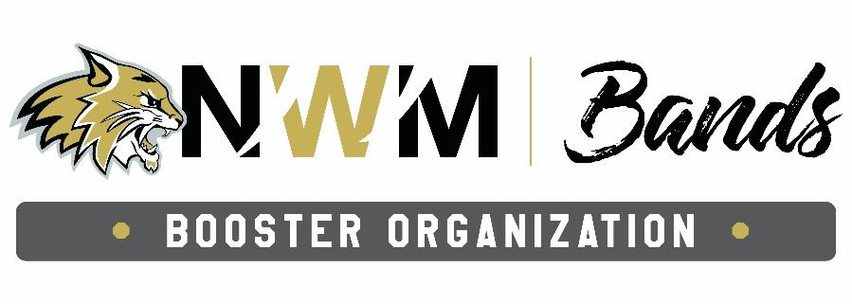
Jill Denefrio, President
Heather Clear, Vice-President
Angie Francisco, Treasurer
Amanda Kriesch, Co-Secretary
Stephanie McConnaughey, Co-Secretary

Band Booster Club Executive Meeting – 6/2/26 at 6:00pm

Meeting started at 6:00pm

Attendance

-Dan Duffield, Jill Denefrio, Angie Francisco, Amanda Kriesch, Stephanie McConnaughey

Sponsorship Letters

-Sponsorship letters (post cards with QR code for sponsorship letter link) were mailed on 6/1/26 to all buisness members belonging to the Chamber of Commerce
-Discussed hand delivering additional cards to businesses not members of the Chamber of Commerce – additional cards are available if needed

Need for Next Year Marching Season

-Discussed if additional bibs for next season are needed or not – Mr. Duffield will order and additional 5 pairs of large and 5 pairs of extra large bibs
-Discussed repair of Vibraphone
- Discussed work on cart for drums and rack for drums – Will modify and use the cart we have for drums

Props

-Discussed ordering cardboard briefcase style boxes with handles from Uline for briefcase props-Will order 18 ¼ x 11 3/8 x 2 11/16 boxes with handles from Uline x 100 boxes
-Discussed using faux leather/fabric or contact paper to cover boxes to make more realistic and adding something into each box to add some weight to it.
-Discussed need for at least 2 working briefcases to use for props that open
-Discussed Boosters sending out a group text to all who may be able./willing to work on bigger field props such as drum spinner and Gem tower, in case people are not receiving Parent Square messages due to summer break
-Discussed idea for Gem tower, have gem made out of something like plexiglass and have it light up. It needs to be able to “disappear” somehow. Discussed a column that flips over or spins to hid the gem, as well as, hiding the gem when a flag covers it. Gem tower will be behind 2 frames and then they will part and gem tower will come out from between them.

Fundraisers

-Discussed fundraiser options for next year:
-Texas Roadhouse Rolls - Kids
-Car washes - Kids
-Raffles for directing the Fight Song between the 3rd and 4th quarter of home football games -Boosters
-Raffle for gift basket or such at events throughout the year -Boosters
-Bingo (need to find new location and get bingo supplies) -Boosters
-Band shirts – “I’m here for the halftime show!” or “I’m with the band!” - Grafix Connection vs Zeffy
- Bake sales throughout the year -Boosters
- Doughnut sales – Krispy Kream vs Hurts Donuts -Kids
-Homecoming Dance -Boosters
- Dunk tank at something like Celebrate Neosho or Fall Festival -Boosters
- Fill in the instrument pages for kids to take home -Kids
- Various fundraisers through Zeffy -Boosters
- Discussed fundraisers that could be done at the Wildcat Kickoff – Bake sale, sell T-shirt, sell fans/cooling towels, sell lemonade -Boosters

Band Camp

-Watermelon from churches
-Shaved Ice truck
-Fire truck
- Discussed talking to Tropical Smoothie or Wendy’s to see if the would donate or discount cold treats
-Discussed having meals to serve kids

Miscellaneous

-Discussed Zeffy – how does money transfer and how long
- Amanda will set up Zeffy account
- Discussed Color Gaurd flag inventory – flags from previous years need inventory take to make available for sale
-Discussed dividing up flags for inventory vs work day – decided to schedule work day for all that want to help to meet at the school to do inventory

Next Booster Club meeting 7/7/26 at 6:00 pm

Meeting ended at 7:34 pm

