Booster Meeting Minutes
February 3, 2026

In Attendance:
Dan Duffield, Jill Denefrio, Alfred Hagan, Angie Francisco, Stephanie McConnaughey, Ryan Chapman, Karl Kriesch, Amanda Kriesch, Heather Clear

Minutes- Posted on Band Webpage www.neoshoband.com

Financial Report
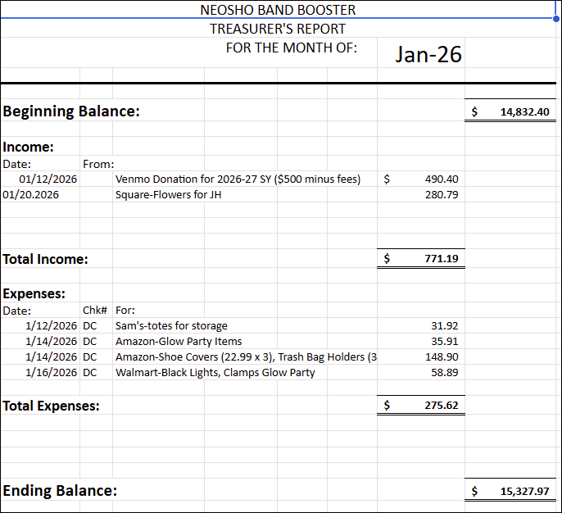

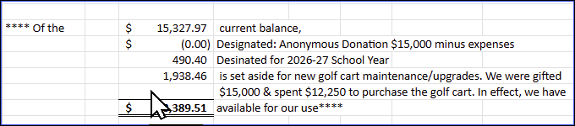

Motion made by Stephanie to approve the financial report and seconded by Amanda. The financial report was approved.

2026 Marching Competitions
- September 19 – CJ (Carl Junction) Marching Festival
- September 26 – Mt. Vernon Marching Festival
- October 3 – Valhalla Marching Festival
- October 17 – Maple Leaf Festival & Morning Rehearsal
- October 23 – 24 – Bands of America – St. Louis
Jazzam
- April 18
- Concessions
- Hospitality room
- Trophies
  - Need information for design of Trophies
  - How many needed? Maybe 9
Jazz Band
- April 16 – Boosters pay for meal – Kansas City
- Snacks for KC trip
Concert Band
- March 3 – Concert – nothing needed from boosters for this
- March 10 – Band Concert
- April 2 – Concert Band Festival
  - Snacks
Organizing
- March 1 – 12:00PM
  - Organize under the bleachers
  - Tote-to go – put together totes for travel
  - Sewing and hair kits
  - Sign Up Genius - Jill

Uniforms to cleaners
- Mr. Duffield will reach out to Jr. High about cleaning the uniform bibs.

Fundraisers
Coffee & Snacks
- May have fundraiser in March

Chili and cinnamon rolls
- Discussed having the chili and cinnamon fundraiser
- Not having this fundraiser at this time

Springfield Cardinal Baseball Game
- April 12
- Sell Tickets

Table Covering banners
Alfred H working with designer

Sell:
Band uniforms
Hats
Silks – discuss with Mrs. Gorman
Props
Mr. Duffield will provide links to sell band items

Next regular Booster Meeting will be March 5, in the band room

Meeting adjourned: 7:00 PM

